**Node Package Management (NPM)**

**“Humans are allergic to change,” she once said.**

**“They love to say, ‘We’ve always done it this way.’**

**I try to fight that.**

**That’s why I have a clock on my wall that runs counter-clockwise.”**

**Grace Hopper.**

**Pioneering Computer Scientist.**

# Hands on understanding NPM

Following are proposed a series of mini exercises that combine the use of a previously chosen npm package and JavaScript basic fundamentals.

*Before starting* create a folder called *Assignment 1* on your Git Repository to commit all the exercises.

## Exercise 1.1: Yoda’s wisdom

First of all, install the npm package [crazy-quotes](https://www.npmjs.com/package/crazy-quotes) and take a look at the API.

The goals of this exercises are:

1. Print in the terminal all the quotes that have been said by the character *Yoda*.
2. Of all Yoda’s quotes, print a single one (randomly) in each execution.

Looking for hints?

* [Map, filter, reduce in JS](https://code.tutsplus.com/es/tutorials/how-to-use-map-filter-reduce-in-javascript--cms-26209)
* [Iteration methods](https://www.itdo.com/blog/javascript-metodos-de-iteracion/)

The expected output for exercise A is:

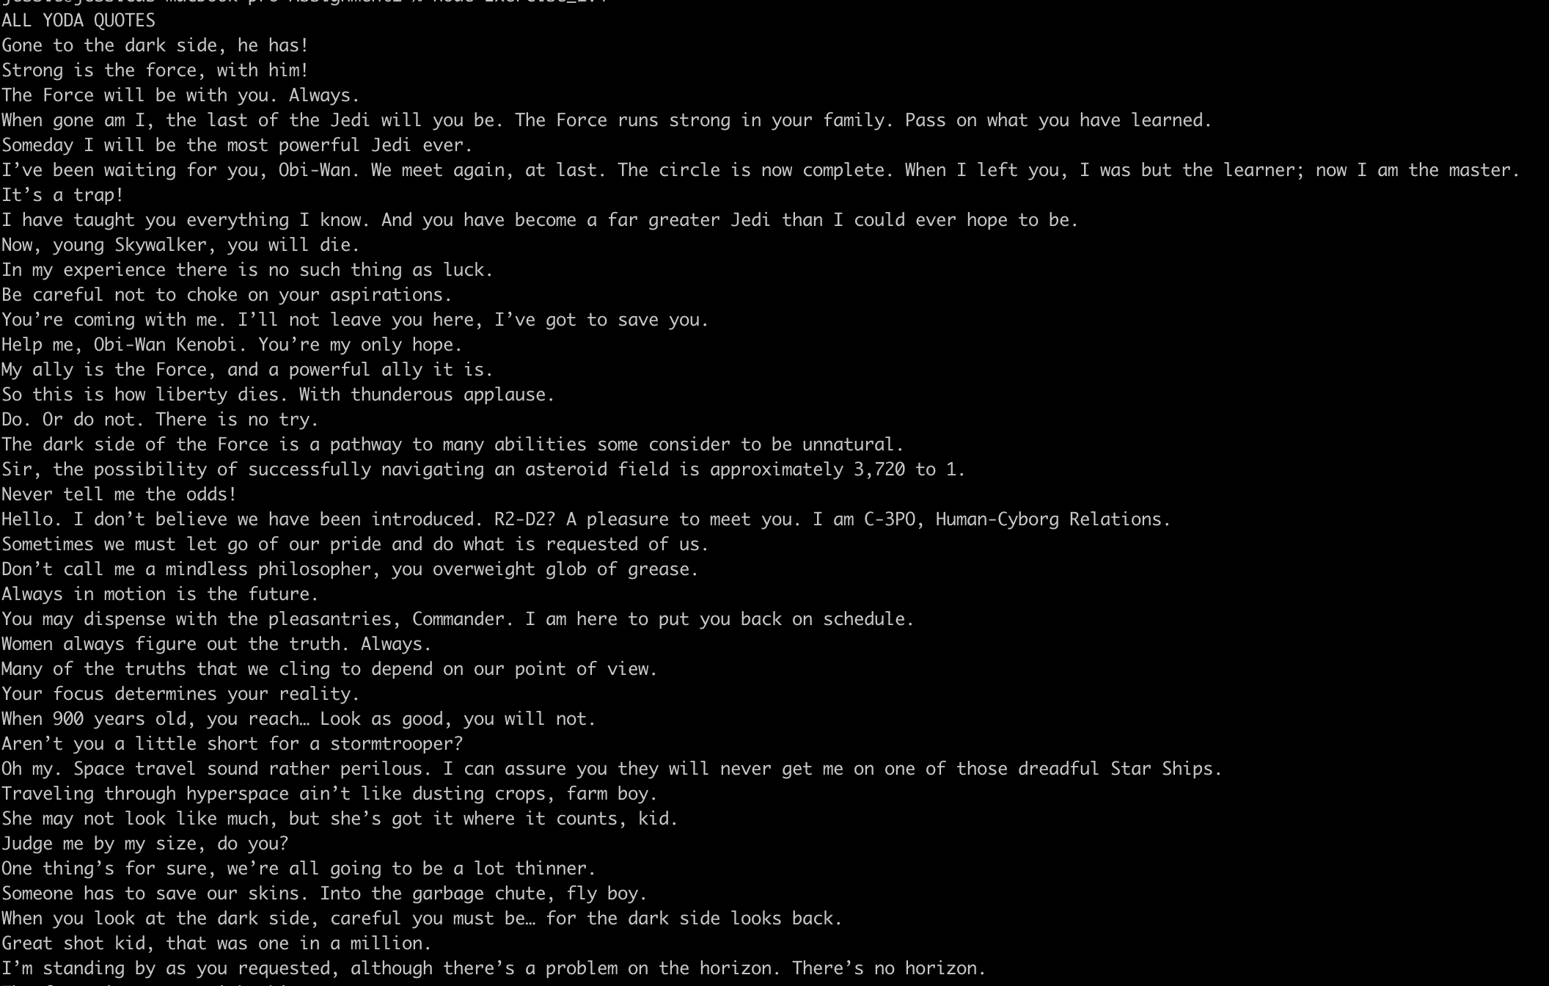

The expected output for the exercise B is:

*Execution 1*



*Execution 2*



## Exercise 1.2: Color fruits!

First of all, install the npm package [chalk](https://www.npmjs.com/package/chalk) and take a look at the API.

The goal of this exercise is to style the user’s favorite fruit (user input via command line).

To do that:

1. You should prompt on the console the question *What is your favorite fruit: oranges, bananas, strawberries or kiwis?* (The user must answer it)
2. Depending on the user’s answer you should style each fruit as follows:
   1. oranges: orange text
   2. bananas: yellow bold text
   3. strawberries: red underline text
   4. kiwis: green inverse text
3. Take into consideration that only those four fruits are acceptable. Any other fruit should not be considered and the following message should we show: *Sorry we don’t have this fruit available ;(*

Expected outputs:







**Note** that it should not matter if the orange is upper or lower case.

Looking for hints?

[Step by step: How to prompt for command line](https://nodejs.org/en/knowledge/command-line/how-to-prompt-for-command-line-input/)

### **Extra**

Add the corresponding emojis to each output. You can take a look to <https://emojipedia.org/>

Expected outputs:

